**South Willesborough and Newtown Community Council**

[**www.southwillesboroughnewtown-cc.gov.uk**](http://www.southwillesboroughnewtown-cc.gov.uk)

**Minutes of the Ordinary Council Meeting held on**

**Monday 14TH JULY 2025**

**JULY 2025 Minutes**

The Chair opened the meeting at 7:00pm

In attendance, Cllr Sue Mullan (SM) Chair Cllr Paul Bohill (PB) Vice Chair Cllr Steve Campkin (SC) Cllr David Mullan (DM) Cllr Eric Parkinson (EP) Cllr Malcolm Webb (MW) Cllr Andy Hodges (AH) Cllr Lauren Corbett (LC)

Also, in attendance Sarah Evans Community Council Manager (SECCM) and 6 members of the public.

**139/25 Record attendance and list apologies for absence**

Ashford Borough Council, Ward Councillors, Al Arnold, Thom Pizzey.

**140/25 Declarations of pecuniary, other significant or voluntary interest**

Councillor A. Hodges declared a pecuniary interest in items 114/25, 150/25 and 149/25

**141/25** **To agree the Minutes of the Annual Meeting of Council May 2025**

It was Proposed EP and Seconded DM that the Minutes were a true record of the meeting and the chair signs them.

**142/25** **To review and evaluate the SWAN SALUTE TO THE 1940S Saturday 5th July 2025 and agree follow up actions.**

**Resolved:- Proposed EP Seconded MW and Agreed unanimously**

1. **To receive and note the positive event feedback, statistics on attendance, participation, business contribution to provide goods and services, stall holder feedback, business feedback and volunteer and steward feedback**
2. **To agree the budget monitor for costings, income and expenditure, also, confirming the event was brought in on time and on budget, income for the event £7414 subject to receipt of one outstanding invoice higher than budgeted at £5500.**
3. **To write a formal letter of complaint delegated to SECCM for the recovery costs and the generators due to the power failure and incorrect communication on generator sizes provided by Speedy Hire.**
4. **To make a donation of £100 to Ashford Repair Café Charity, payment to be made immediately.**
5. **It was resolved in pursuance of the powers conferred by s. 137 of the Local Government Act 1972 (as amended) and being of the opinion that the expenditure satisfies the requirements of that section, the council approves expenditure in the sum of (1) £1208.92 to Mr A. Hodges for the provision of hygiene bank for SWAN residents (2) £86.85 by council debit card to Asda for provision of fruit and vegetables for the benefit of all SWAN residents. 3) To the purchase by council debit card of 1 £10 voucher as a gift for a volunteer on council parking. 4) Donation to Ashford Repair café £100 as above point 4**
6. **To purchase by council debit card Amazon 1x Garden Games Connect 4, 1x inflatable dice, to return to property lent by Kings North Parish Council.**
7. **1x Radio BAOFENG BF UV-5R-8-WATT Dual Brand to replace property of Roger Crouch to reimburse SECCM £37.09 – emergency decision**
8. **To reimburse Mr Roger Crouch £245.30 event organiser expenses**
9. **To investigate branded SWAN CC gazebo, to be reviewed by Communications Workings Committee – action SECCM**
10. **Items found lost property to continue posting on social media lost property and return wherever possible.**
11. **To write to Cherry Tree Nurseries to formally thank them for their provision of car parking.**
12. **Write to all Dignitaries, Performers and Photographer to thank them for their contribution.**
13. **To investigate costs and funded applications for Digital Storytelling of VE 80 VJ DAY – action SECCM**
14. **To send to KALC SWAN salute press release images and a brief on rising costs bank and Salvation Army partnership with SWAN CC.**

**143/25 To receive reports from**

1. **KALC representatives,**

SM gave a report on the most recent area committee.

1. **Police and Neighbourhood Watch representatives,**

Police did not attend; email correspondence was reviewed report from Neighbourhood Watch was received and noted.

1. **Ward Councillors,**

In the absence of both ward councillors, Cllr Campkin gave an update on items for the agenda of upcoming full council agenda items.

1. **KCC Councillor,**

KCC Councillor Dean Burns attended the meeting, gave a comprehensive overview of KCC actions and objectives and responses to SWAN HIP which was delegated to Planning and Highways Committee.

1. **Observer to Newtown Railway Works Development.**

PB and SECCM gave an update on the strong changing strategy and vision for the Newtown Development Agreed unanimously to invite AIDC Limited to the September meeting of SWAN CC.

**144/25 Meeting adjourned for members of the public to raise questions on items on the agenda. (This item will last no more than 15 minutes in total**)

Meeting adjourned at 8:12pm Mr David Smith thanked the council for his recent KALC award and SWAN CC award, he was most surprised and deeply grateful for the awards which were most unexpected and his appreciation of the award ceremony at KCC Stonehouse.

The meeting reopened at 8:15pm

**145/25 To receive and note the Minutes of the June 25 Planning and Highways Meeting**

**Resolved:- Proposed SC Seconded LC and Agreed unanimously to receive and note the Minutes of the June 25 Planning and Highways Meeting**

**146/25 To agree a response to the KALC Local Government Reorganisation survey**

**Resolved:- Proposed EP Seconded DM and Agreed unanimously to the full response of this consultation**

**147/25 To agree a response to the Ashford Borough Council Housing Survey Cllr Corbett**

**Resolved:- Agreed unanimously to delegate item to LC and PB**

LC left the meeting 8:30pm

**148/25 To consider a donation to Thorne Rescue Cllr Campkin**

**Resolved:- Proposed EM Seconded PB and Agreed unanimously**

**It was resolved in pursuance of the powers conferred by s. 137 of the Local Government Act 1972 (as amended) and being of the opinion that the expenditure satisfies the requirements of that section, the council approves expenditure in the sum of to £100 donation, immediate payment to Thorne Rescue (2) to delegate Communications CTEE to advertise work of the organisation and donations in newsletter and on social media.1**

**149/25 To receive a report of the Community Council Manager on the Newtown Memorial Bench and agree actions**

**Resolved:- Proposed EP Seconded MW and Agreed unanimously**

1. **To accept the final design for the bench from Glasdon, to pay on invoice the net payment being £1894.99 and to update the policy that the cost for memorial plaque on the bench will be £70.00.**
2. **To ensure correct wording for the plaques is received from the Alfred Arms.**
3. **To bring quotations for fitting installation to the next meeting of FGP Cttee.**

**150/25 To receive a report of the Community Council Manager on the Stirling Road Playpark and agree actions**

**Resolved:- Proposed PB Seconded SC and Agreed unanimously**

1. **To accept the quotation from Hodges Building and Maintenance LLP in the amount of £11983.12 +VAT £14379.74 to be funded by Ear Marked Reserve (1) Playground improvements (2) Area Committed Spend**
2. **To purchase Clifton Picnic Bench Enviropol brown slats ground fixing kit plaque x1 from Glasdon, payment upon invoice £939.30 excluding VAT £1127.16 inc. VAT, plaque to read ‘Installed by South Willesborough And Newtown Community Council 2025’**
3. **To purchase Stanford Bench Enviropol brown slats ground fixing kit plaque x4, £1894.99 +VAT form Glasdon.**
4. **Installation costs for Stanford Bench to be brought to FGP Cttee for review.**

**151/25 To agree the payments listing (attached), new beneficiaries, endorse any payments agreed by email and any deposit key refunds required.**

**Resolved:- Proposed SM Seconded DM and Agreed unanimously to the following 1) payments listing table 1, endorse all payments agreed by email table 2 below.**

**2) It was resolved in pursuance of the powers conferred by s. 137 of the Local Government Act 1972 (as amended) and being of the opinion that the expenditure satisfies the requirements of that section, the council approves expenditure in the sum of £105.97 to reimburse to SECCM for the purchase of 3x Community Awards and plaques.**

**3) To agree retrospectively the increase in payment from £1475 to £1500 to Mr Roger Crouch and the increase in payment from £304 to £325 net for Four Jays Toilets both of which were previously agreed by email.**

**4) To note the cancellation of payments 1) refund for Clerk for generators for SWAN Salute previously agreed by email, due to full refund to Clerk by supplier. 2) event organiser fee for assistant to Mr Roger Crouch as not hired for event.**

**5) To note the reduced price for payment for Fixman Chain Agreed April Council 25 due to items being on sale at time of purchase Expected to be B&Q £94.56 Fixman actual cost £57.74 inc VAT**

**Table 1 all payments agreed.**

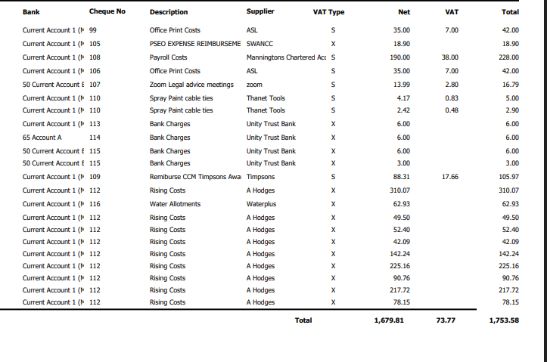

Currnet Account 1

ClerkReimbursement

**Table 2 All payments agreed by Email were endorsed as detailed below.**

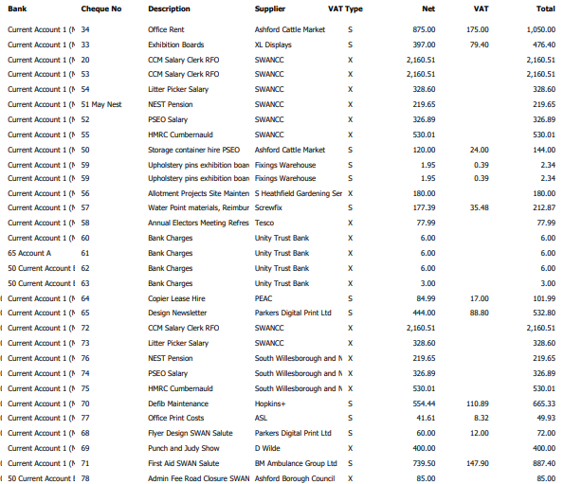

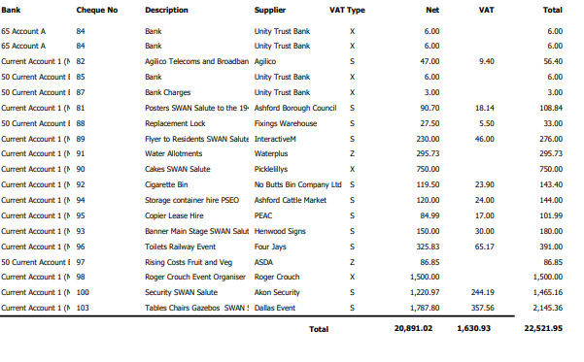

**152/25 To agree under Section 12a of the Public Bodies (Admission to Meetings) Act 1960 to exclude members of the public from the following part of the meeting. Item152/25**

**Agreed unanimously 8:50pm the meeting was closed to the public.**

**153/25 To receive and note legal advice relating to the SWAN Centre and agree actions**

**Resolved:- Proposed EP Seconded DM and Agreed unanimously to receive and note legal advice and to return legal information request. Action SECCM**

**All correspondence is confidential to the council and not open to FOIA**

**Meeting reopened to the public at 8:54pm**

**154/25**  **Urgent Correspondence**

1. **Email IBF Facility planning application received and noted**

**155/25 Forum of Exchange**

Salvation Army Ashford Corps will be achieving training to become a recovery church supporting and endorsing all the work in this transformative space.

SWAN Young Farmers Kent County Show update tremendous success at the Kent County Show winning Champion Cow and Champion Handler, placing in every category across a wide variety of ages.

**156/25 To agree the date of the Next Meeting as Monday 1st September 2025 and items for the Agenda**

The date of the next meeting was agreed as Monday 1st September 2025. Items proposed for the agenda were Crowbridge Road, Riverbank Way overgrown vegetation.

There being no further business to discuss, the Chair closed the meeting at 9:03pm.

Signed _____________________________________________ Date________________

Appendix of Reports

SWAN Salute

Memorial Bench

Stirling Road Playpark

**A review and evaluation of the SWAN SALUTE TO THE 1940S**

The SWAN Salute to the 1940s was a **resounding success**—delivering cultural enrichment, community connection, and historical education in a vibrant and accessible format. It exemplified what a local Council-led event can achieve when supported by volunteers, partners, and good planning.

**Attendance & Participation**

* Estimated at least **1,500+ attendees** over the course of the day, there was a wide reach of attendees with visitors from London Buckinghamshire Hertford and Essex and East Sussex as well as Shadoxhurst, Bilsington Ruckinge, Hamstreet and wider areas of Ashford to name a few. Plus most importantly a very large turn out of local residents.
* Diverse demographic: families, veterans, young people, children, local history enthusiasts
* Approx. **35 volunteers** assisted in stewarding, setup, and hospitality
* **15 LOCAL community groups contributed to the displays and preparation on the day**
* **9 performers/groups**, including Five Star Swing, The Silhouettes, Winston Churchill impersonator, Wayne Stunt and Action team, My Charleston dancers, Cinque Port Lindy Hoppers, Miss Victoria and the amazing Compere Town Crier from East Sussex
* **In addition to performers 36 Businesses were used to provide good and services for the event to SWANCC, 9 businesses traded on the day plus community groups SWAN WI, and Ashford Guide Dogs and Ashford Repair café and 2 local charities.**

**Post Event Engagement**

10494 views on Facebook Sunday 6th July.

**Event Feedback**

Dear Sue, Sarah, Peter and the rest of the Team.

I'm sorry not to have written an email before now, to thank you all for all your hard work on putting on The SWAN salute to the 40s, an absolutely fantastic event.

I really enjoyed myself and stayed far longer than I should have ! I loved the displays, the Spitfire,the entertainment, including Winston Churchill ( who was brilliant with the crowd )

and of course the singing. A very good poignant moment was the sound of the Town Crier's bagpipes, one could feel the power of remembrance in the silence that followed.

Thank you for inviting me, and including me in the day, an event that I will not forget for a very long time

Finally, a heartfelt thanks to the whole Team that made the event possible, I personally know that events like this take up a huge amount of time and effort, and I felt the pride of many of the stand holders, guests and

the local residents on the day

with kind regards Sir George Jessel, Bt. DL 

**Cllr Peter Feacey**

I just wanted to extend my sincere thanks to you and the entire team for the *Salute to the 1940s*. I think everyone was truly impressed and absolutely delighted with the event, and I know Sir George enjoyed it immensely.

It was clear how much effort you all put into making the day a true celebration of VE and VJ Day—and I believe you achieved exactly that. The catering was brilliant, and I particularly enjoyed the Prime Minister’s visit. Throughout the day, we were made to feel genuinely welcome.

With warmest thanks,

Peter

Councillor Peter Feacey,

Armed Forces Champion

Ward Member for Godinton,

Ashford Borough Council

Co Leader Ashford Green Party Just a quick line to say a huge thank you to you, the Community Council & everyone involved in putting the Salute to the 40s even on at the weekend! As well as being fantastically organised, it was great to see so many local residents of all ages enjoying a step into the past & a reminder of all we have to be grateful for. The entertainment was just right, the volunteers all worked so hard but looked like they were having fun too, the stalls & organisations all embraced the theme and I can’t wait to see what fantastic community even you’ll no doubt already be thinking about for next year! Thanks to all! Best wishes Mandy

What a truly splendid event on Saturday — my warmest congratulations to everyone who played a part in making it such a success.

**CLLR KATE WALDER**

A heartfelt thank you SWAN community council and to Sarah for the most divine afternoon tea — an elegant and gracious touch that made the day all the more special.

Events like these are far more than just a pleasant afternoon; they are the very heartbeat of our local communities. They bring people together, foster a spirit of inclusion, and remind us all of the strength, warmth, and resilience that define Ashford and The Weal

**Comments online Kentish Express ran the event images and wrote**

[**Kentish Express**](https://www.facebook.com/KentishExpress?__cft__%5b0%5d=AZVJaNpXLZAIr-WCWb4-lnmzBaTrWr-MZOVyIDMb8fMBC7_1UUD9EqSlSaEdy_H80lRosj8Z1Gko2PnRo8qk_hczH_fZN9np6Ws8ET5UTXBGaN3a9NXp8Z2hHTcI8QEsdvuPFWYmr3sg4GYbSw5pP2TvYqoxT4AyVbWPnd2XzLsHVGdr39TFwq9psT9A1Qc3H4-kLHdt_7ZsNZHO0SZD0rKucYk8GCKm7bce8UFu8y4AeA&__tn__=-UC%2CP-y-R)

[**21 hours ago**](https://www.facebook.com/KentishExpress/posts/pfbid02qAK9y6d6rKdVUnP6ijxQYdnbAjqLQseKrWvMt3WAS4p1KXj8fh7GQmcokCkWSTcJl?__cft__%5b0%5d=AZVJaNpXLZAIr-WCWb4-lnmzBaTrWr-MZOVyIDMb8fMBC7_1UUD9EqSlSaEdy_H80lRosj8Z1Gko2PnRo8qk_hczH_fZN9np6Ws8ET5UTXBGaN3a9NXp8Z2hHTcI8QEsdvuPFWYmr3sg4GYbSw5pP2TvYqoxT4AyVbWPnd2XzLsHVGdr39TFwq9psT9A1Qc3H4-kLHdt_7ZsNZHO0SZD0rKucYk8GCKm7bce8UFu8y4AeA&__tn__=%2CO%2CP-y-R)**·**

**🇬🇧🇬🇧🇬🇧Newtown Green certainly marked the 80th anniversaries of VE Day and VJ Day in spectacular style on Saturday…**

**Whats on Magazine were present on the day and ran the event on their social media**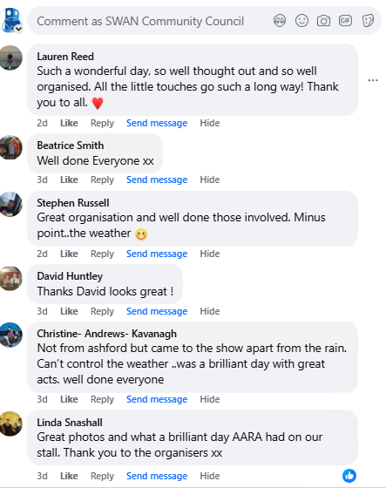

**Business feedback**

**Ashford Caterers “Best event in Ashford great attendance at lunchtime incredible displays, unbelievable it was so busy with the Kent County Show Ashford Festival at the same time brilliant event.”**

**Harolds Hog roast sold 300 portions and it was a great event**

**Alfred Arms the party carried on until 1am in the Pub a great event and a great support to the business.**

**Frogs Island Ceramics Thank you for having me it was a great day.**

**Safety and Security**

No accidents reported to First Aid and Control 2 plasters were given out all day

3 small incidents linked to the bar with 2 security officers this was dealt with discreetly promptly and had impact on the event.

1 incident of abusive behaviour towards a volunteer over parking stewarding this was confronted and a small apology received**. Recommendation TO REVIEW ATTENDANCE OF CHARITY AT FUTURE EVENTS – A GIFT VOUCHER MIN £10 for the volunteer**

**Challenges**

**Power**

**A second generator was ordered as an Emergency decision to ensure power for the Homefront and support**

Wrong generator was delivered correct generator was brought and additional fly leads.

Wrong generator measurements were given and Recovery team had to be brought in to secure the generators and these were then returned to Speedy Hire

The generator for the main stage was delivered without the prepaid fuel

Additional fuel was secured by PSEO and volunteer but even with the Speedy engineer on the phone the generator could not function. The second generator was used to power the stage which meant Ashford Repair Café were without power **Recommendation £100 DONATION TO THE CHARITY**

No effort from Speedy Hire to contact the Community Council Manager a visit to the site returned all payments and finally an apology was given, however no commitment to cover the recovery cost. **Recommendation WRITE FORMAL LETTER OF COMPLAINT**

**Parking**

Despite many communications in advance cars could not be parked on the Green it was still being pushed on the day.

Whilst it was dealt with if a future event is held there will need to be a drop and go Marshall for each station – to reduce any delays in removing vehicles .

Accessibility – the number of blue badge vehicles was higher whilst we managed it on the day we will need to consider how we handle higher numbers of vehicles in the future. It is a challenge geographically for parking and the site is fully used for the event.

**Hospitality**

Friday 6:58pm The 2nd key food vendor cancelled. Cllr Hodges was able to secure

an amazing barbecue with the team from Red Muncbox Ltd working through the night to deliver an incredible service. This really supported the business . they also contributed £80 additional income for the event.

A coffee cart and candy floss cart which had their highest ever trading.

**Performance against budget**

**The event budget was delivered on time and on budget full breakdown below. This was possible because of the generous donations to the event in volunteer gifting time removing costs for street party set up marshalling stewarding and take down as well as the Homefront display provided by AARA and Make Do and Mend being created by the SWAN Office team.**

**The rising costs budget hygiene was delivered on time and on budget Dig for Victory was delivered on time and budget expected to be within limit agreed. Fareshare bill awaited from Ashford Borough Council**

**Budget Income and Expenditure performance against budget TO AGREE**

|  |  |  |
| --- | --- | --- |
| **Event Budget** | **Income** | **Expenditure** |
| **£15000** | **£5500** | **£9500 Precept Plus income £15000** |

**Detailed cost centre breakdown in appendix To Agree**

|  |  |  |  |  |
| --- | --- | --- | --- | --- |
| Event Budget  Spend to date £ | Income £ | Final Cost £ | Cost per tax base 24/25 | Cost per household |
| 14532.55 | 7414 | 71178 | 7117/1254  £5.67 | 2060 Elec Roll 2020  £3.45 |
| Rising Costs Budget |  |  |  |  |
| £1950 | 0 | 1294.98 TO DATE | TBC | TBC |
|  |  |  |  |  |

**Sustainability Waste Management and Reduction**

|  |  |  |
| --- | --- | --- |
| Waste |  | Waste Diverted from landfill |
| Cardboard boxes | 32 | 32 |
| Waste bags | 36 | 257.72kg fareshare scheme application |
| Costs | nil |  |

**Council Budget Headers applied through the Event**

|  |  |  |  |
| --- | --- | --- | --- |
| Staffing | To Review by FGP |  |  |
| PSEO | 6AM- 9PM  1.5 hrs Sunday  2 days overtime June  2 days overtime July  Diesel £13.80  Mileage 10 miles | 15 HOURS  6 AT DOUBLE TIME | To Agree |
| Litter picker | 4 hours | Standard time | To Agree |
| Stationary and Equipment | To Review by FGP | As forecasted |  |
| Comms | To Review By Comms Cttee | As forecasted |  |

|  |  |  |
| --- | --- | --- |
| **Actual** | **£7414**  **£250 outstanding food vendor but will be paid good supplier** | **£14532.55**  **Includes following deduction**  **-£489.17 refund Speedy hire paid by CCM expense not reclaimed.**  **Awaited deduction there have been issues with collection so is in question.**  **-£75 FLAGPOLE DEPOSIT** |

|  |  |  |  |
| --- | --- | --- | --- |
| **Rising Costs** |  |  |  |
| **Budget** | **Expenditure** |  |  |
| **£1500** | **Hygiene Bank** | **£1208.09** | **S137 SPEND PAYMENT TO A HODGES** |
| **£450** | **Dig for Victory** | **422.72 kgs / 950.40** |  |
|  | **Fruit and Vegetables** | **£86.89**  **165kgs approx** | **S137 SPEND PAYMENT TO S EVANS CCM** |
|  | **FARESHARE** | **257.72 kg**  **63..5 trays**  **Expected cost £2.50 per tray invoice awaited** | **S137 PAYMENT TO ASHFORD BOROUGH COUNCIL FARESHARE** |

**Overall Opinion of the Event:**

The *SWAN Salute to the 1940s* was an **outstanding success** on all fronts—community engagement, cultural enrichment, historical education, and local pride. The event was well-attended, well-organised, and celebrated by a wide range of participants, from local families to regional visitors and dignitaries. It stood out not only for its atmosphere and activities but also for its meaningful moments of remembrance, particularly the Town Crier’s bagpipes and the Winston Churchill reenactment.

Feedback from public figures including **Sir George Jessel**, **Cllr Peter Feacey**, and local businesses underscores the value and impact of the event. Operational challenges were managed professionally without disruption to the public experience, and the event was delivered **under budget** with excellent use of volunteer support.

In summary, the event clearly demonstrated the capability and commitment of SWANCC to deliver large-scale, meaningful community events, and should serve as a **benchmark for future initiatives**.

A review of how this event makes Newtown and South Willesborough Special

Newtown and South Willesborough are rich in community spirit, cultural diversity, and historical significance. As one of Ashford’s most engaged areas, these neighbourhoods demonstrate a rare blend of heritage pride and forward-thinking community development. The success of events like the SWAN Salute to the 1940s highlights what makes the area unique:

* **Strong Volunteer Ethos**: A dedicated base of local volunteers, residents, and councillors who consistently give their time and energy to enhance local life.
* **Diverse and Inclusive Community**: Families, young people, veterans, newcomers, and long-time residents come together to celebrate shared values and histories.
* **Local Leadership and Partnerships**: The South Willesborough and Newtown Community Council (SWANCC) effectively partners with businesses, charities, and civic leaders to deliver impactful events and initiatives.
* **Pride in Place**: From carefully maintained green spaces like Newtown Green to the celebration of local history, there’s a deep sense of identity and pride in the area.
* **Creative and Cultural Energy**: The area supports arts, music, education, and storytelling—bringing history to life in a way that’s accessible and meaningful for all ages.

Newtown and South Willesborough are a model of what can be achieved when grassroots passion meets structured civic support—making them not just places to live, but places to belong

**Forward Actions Recommendations**

**Implement all recommendations Agreed**

**Write to all Dignitaries, Performers and Photographer.**

**Consider funding applications for Digital Storytelling of VE 80 VJ DAY and a printed book for the event.**

Appendix

Detailed Cost Cente Breakdown SWAN Salute

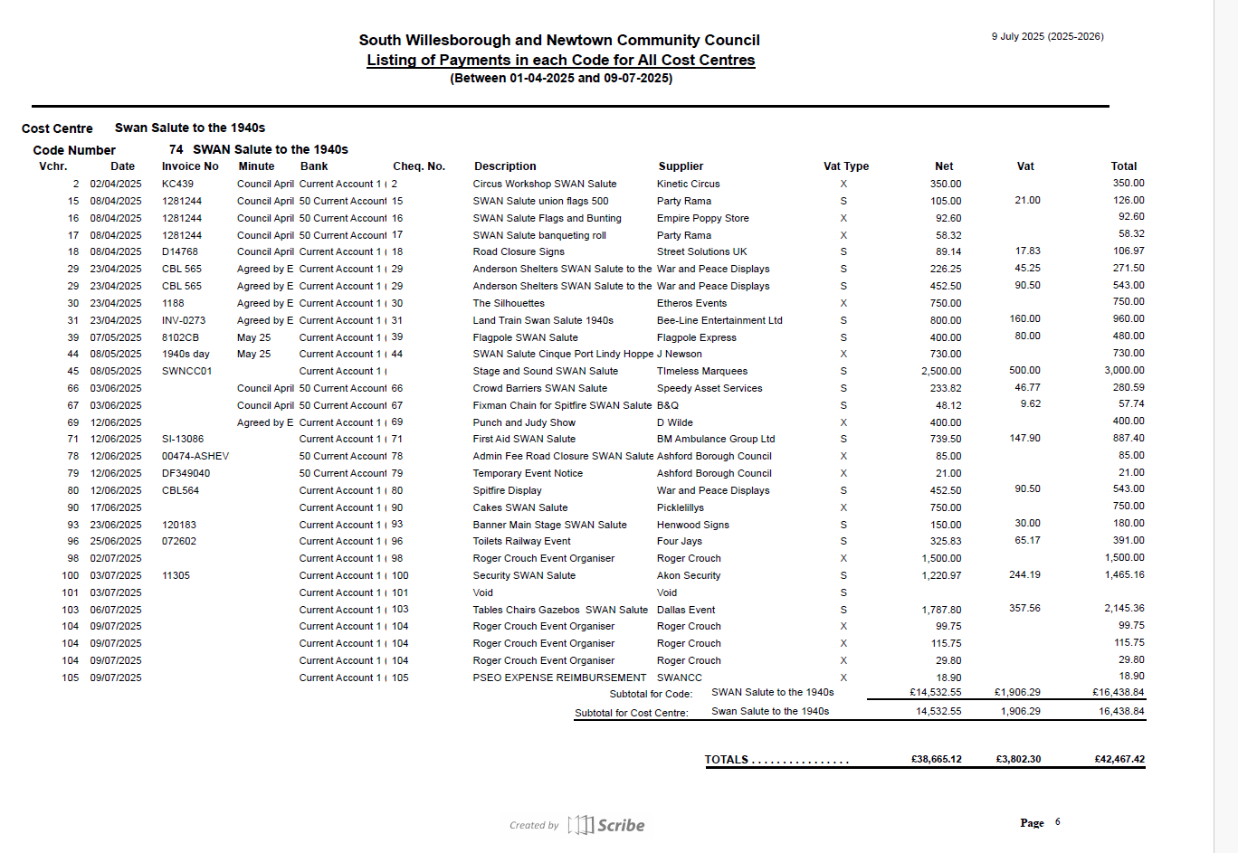

**A report of the Community Council Manager on the Memorial Bench Newtown Green.**

The final design has now been received and requires approval attached with this report. The permission for its installation is received from Ashford Borough Council.

The net payment is £1894.99 to agree to pay on invoice

The wording for the 4 memorial plaques is waited from the Alfred Arms. The bench will take 4 -6 weeks from point of order to deliver and a full quotation for installation requested from Hodges Builders to fit and install.

The finish for the fit and installation will ensure the bench is cared for and the policy then needs to be communicated and the fees agreed for future plaques is as below:-

Plaque size 150mm x 40mm with up to 4 lines of text.

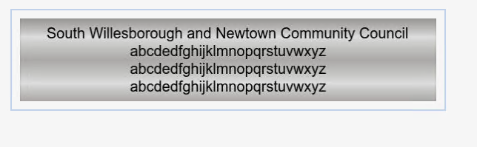

|  |  |  |  |
| --- | --- | --- | --- |
| Plaque Providers | Brunel Engraving | Timpson’s | Other Costs |
|  | **£52.28 net of vat**  **Order online for delivery custom plaque service** | **£33.00 inc vat**  **Ss 5x2 inch cut to fit and engraved** |  |
| Staff time |  |  | **£33.00**  **2 hours per plaque**  **Admin and installation** |
| Postage if required for admin |  |  | **£4.00** |
| Recommended Price |  |  | **£70.00** |

Sarah Evans

Community Council Manager

11.7.25

**A report of the Community Council Manager on Stirling Road Playpark Refurbishment**

**Introduction**

This report provides a formal assessment of three quotations received for improvements to the outdoor play area. The scope includes planters, a mud kitchen, picnic bench installation, and associated works. Each quote was reviewed for completeness, value for money, durability of materials, play value, and supplier reliability.

The responsibility for the playpark and all existing play equipment remains with **Ashford Borough Council**. As such, **ongoing inspections, maintenance, and safety compliance** related to the installed equipment are managed by the Borough Council and do not fall under the remit of the Council or the selected supplier.

For this reason, **inspection regimes, long-term risk assessments, and safety audits have not been included** in the scope of quotations or this procurement process. Any future equipment installed by the approved contractor will be subject to handover procedures in accordance with Ashford Borough Council’s established protocols.

An additional estimated cost of **£3,500** applies to any quotations that excluded key elements such as:

* Offloading and handling of delivered goods
* Topsoil for planters and mud kitchen
* Installation and filling of growing boxes
* Installation of picnic bench and waste bins

These factors were taken into consideration when evaluating the overall value and feasibility of each proposal

**2. Summary of Quotations**

1. **Timotay** Timotay pride themselves on “an award winning design team who have taken the initial brief and created a space to enrich and maximise learning and play opportunities in your outdoor environment” TIMOTAY asked if we were planning any other works and the picnic bench and litter bin were included in the price however the bench is wooden and potentially not durable for an outside play park the installation cost will increase for council to supply the product. When following up on the quote and its progression Timotay withdrew the planters as not suitable for the playpark. No guarantee on the mud kitchen was supplied. Site visit request declined

**Total Cost:**  **£9,073.12+ VAT plus £3500 estimated additional costs**

* **Key Points:**
  + Included a wooden picnic bench and litter bin.
  + Withdrew the planters from their proposal, stating they were not suitable for the playpark.
  + No site visit request.
  + Excellent communication and design presentation
* **Issues:**
  + Additional installation costs would apply if the Council supplied a more durable alternative.
  + Lack of commitment demonstrated through withdrawal of items and did not attend site.
* **Recommendation:** **Reject**  
  The quotation lacks key components, raises concerns over product suitability, and demonstrates a lack of durability and sustainability.

1. **Broxap Street Furniture** Broxap Street Furniture suppliers are recommended by SLCC and numerous Councils and Municipal Services. Offer the SWAN Planter 2.4m x 2.6m will plant 1 fruit tree Mud Kitchen Dimensions: 1.4m 0.7mwide x 0.6m – 0.840m high. The products whilst durable, reliable innovative and functional are quite small which will reduce their play value which is the whole purpose of the project and have less impact in the area. **Recommendation reject quotation.**

**Total Cost:**  **£9,073.12+ VAT plus £3500 estimated additional costs**

* **Key Points:**
  + Reputable supplier widely used by local authorities and municipal services.
  + Offers SWAN planter (2.4m x 2.6m) and a compact mud kitchen.
* **Issues:**
  + While durable, the products are small in scale and do not offer the intended play or learning value.
  + Limited visual and functional impact in the play area.
* **Recommendation:** **Reject**  
  Despite product quality, the size and play value are insufficient to meet the aims of the project.

**C. Hodges Building and Maintenance LLP**

* Completed Site visit, offered innovative design for planters offers a complete solution built to fit the playpark,
* The mud kitchen will be out of graded and prepared walnut logs which is very high quality long lasting and durable and to the standard of the new trim trail.
* All the concrete base of the picnic bench installation is included and labour is free of charge, the concrete post for new plastic litter bin is included and labour free of charge.
* Includes topsoil for planters and topsoil for mud kitchen. 3) includes Installation of Goods 4) labour for filling planters and mud kitchen 6) installation of picnic bench and waste bins.
* Labour for off-loading is not required and staff time to manage the off loading of goods and costs and staff time and costs to secure the goods for installation is saved which is also a significant saving.
* Reliable and trusted supplier.
* **Total Cost:** **£11,983.12 + VAT no additional costs**
* **Key Points:**
  + Conducted a full site visit and tailored the design to fit the playpark.
  + Custom planters designed specifically for the site.
  + Mud kitchen to be constructed from graded walnut logs—durable and visually in keeping with the new trim trail.
  + Inclusive quote covering:
    - Topsoil and all materials
    - Installation of planters, mud kitchen, picnic bench, and waste bins
    - Labour for offloading, installation, and filling
    - Concrete bases and posts included, with no extra labour charges
  + Eliminates the need for staff involvement in offloading or securing deliveries, offering further cost and time savings.
* **Recommendation:** **Accept**  
  The most comprehensive, cost-effective, and high-quality proposal. The supplier has shown strong engagement, reliability, and alignment with project goals.

**Review based on materials used and warranties**

**Head-to-Head Comparison: Timotay vs Hodges**

| **Category** | **Timotay (Glulam)** | **Hodges (Walnut Logs)** |
| --- | --- | --- |
| **Material** | **Engineered softwood (glulam). Needs regular sealing; less natural appearance.** | **Natural hardwood (walnut). More tactile, durable, and visually engaging.** |
| **Aesthetic Fit** | **Clean, modern look. May clash with natural settings or rustic trim trail features.** | **Organic, rustic look. Complements natural outdoor play environments and blends with surroundings.** |
| **Durability (Outdoor Use)** | **Structurally stable but vulnerable to long-term water ingress if not perfectly sealed.** | **Naturally durable, weather-resistant hardwood (if properly prepared). Excellent for long-term outdoor exposure.** |
| **Play Value** | **Structurally sound but less tactile and engaging. Smaller components noted in quote.** | **Larger, tactile features with high sensory and play engagement – ideal for children’s outdoor learning.** |
| **Design Approach** | **No site visit; withdrew items mid-process; standard catalogue options.** | **Full site visit; bespoke designs fitted to space; cohesive with existing trim trail standard.** |
| **Scope of Quotation** | **Incomplete: missing installation, offloading, topsoil, guarantees. Bench not durable.** | **Fully inclusive: all labour, materials, offloading, topsoil, installation included at no extra cost.** |
| **Supplier Engagement** | **Minimal. Declined site visit. Removed elements (planters) after initial quote.** | **High engagement. On-site assessment, innovative solutions, transparent and responsive.** |
| **Cost Transparency** | **Would require additional council funding for missing installation and product upgrades.** | **Clear pricing. Labour and materials included. No hidden or transferred costs to the council.** |
| **Long-Term Value** | **Lower initial cost but may require ongoing maintenance and replacements.** | **Higher initial quality and lower future maintenance needs due to materials and design integrity.** |

**Overall Recommendation**

**✅ Hodges Building and Maintenance LLP – Preferred Supplier**

**Hodges clearly offers the superior long-term solution, with:**

* **Bespoke design that maximizes the space and complements existing features.**
* **High-quality materials (graded walnut logs) suited for outdoor and high-use environments.**
* **A fully inclusive quote that accounts for all installation, materials, and staff impact.**
* **High play and learning value, which is the core objective of the project.**

**Timotay, despite their reputation, provided a less suitable package for this specific setting:**

* **Their glulam-based offering lacks natural aesthetics and tactile value,**
* **The quote was incomplete, and their withdrawal of key items and refusal to visit site show limited commitment,**
* **Additional hidden costs would likely fall back on the Council.**

**Conclusion and Recommendation**

After careful review, it is recommended that the Council accept the quotation from **Hodges Building and Maintenance LLP** for the outdoor play enhancements. Their proposal offers:

A durable and aesthetically suitable solution * Full cost transparency with no hidden or indirect costs

* Higher play and educational value * A committed and reliable supplier relationship

This option best supports the long-term goals of creating a safe, engaging, and sustainable outdoor learning space for the com

Their proposal offers a complete solution with high-quality, long-lasting materials and minimal additional costs.

This recommendation is based on their proactive approach, tailored design, and inclusive quotation which best supports the objectives of enhancing play and learning opportunities in the outdoor space.

In summary, **Hodges' proposal provides both a better product and a better supplier relationship**, with fewer risks and greater long-term benefit for the children and the community. The natural materials, durability, and all-in-one package make this the most sensible and value-driven choice.

**Budget Monitoring and application of ear marked reserves to agree and Minute**

|  |  |  |
| --- | --- | --- |
| **Expenditure to agree** | **Cost** | **Budgeted Ear Marked Reserves** |
| **Hodges Building and Maintenance LLP** | **£11983.12 +VAT £14379.74** | **KCC Grant £9996.00 Ear Marked Reserve Playground improvements** |
| **Fruit trees & Litter Bin** | **Nil ABC supplied** | **£500 fruit trees £576.84**. **Area Ctted Spend** |
| **Clifton Picnic Bench**  **Enviropol brown slats ground fixing kit plaque x1** | **£939.30 excluding VAT**  ***£1127.16 inc. VAT*** | **£837.91 Area Ctted Spend** |
| **Stanford Bench Enviropol brown slats ground fixing kit plaque x 4** | **£1894.99 +VAT** | **£1338.80 Area Ctted Spend** |
| **Installation costs awaited** |  |  |
| **Total** | **£14817.41 NET** | **£13249.55** |
| **Cost to 25/26 budget** | **£1567.69 NET** |  |

Cost to Community Council to date =£4821.24 per tax base £3.84 per household based on 2060 houses £2.34

Appendix of quotations

Tables of costs for each supplier

Materials review

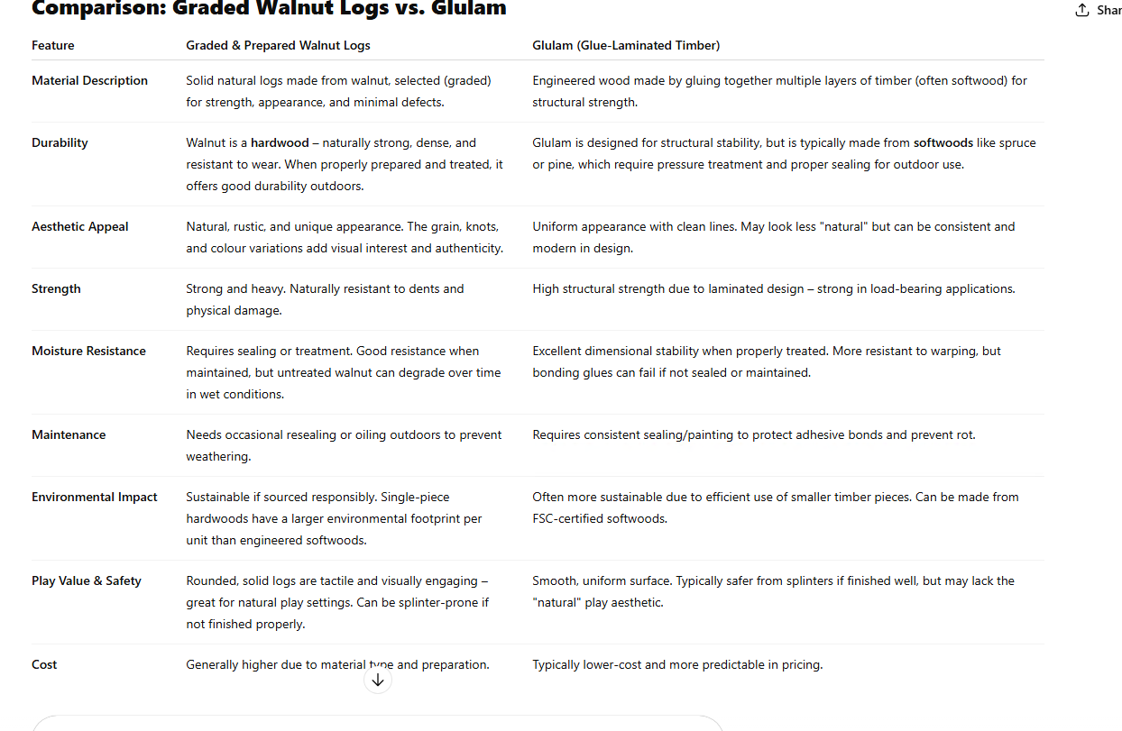

|  |  |  |  |  |
| --- | --- | --- | --- | --- |
| Supplier | Job Number | Items |  | Project total cost |
|  |  |  |  | **£9,983.44** |
| Timotay | 2025-000080-1 | Rustic roofed mud kitchen | £2,034.65 | £9073.12+vat |
|  |  | Picnic Bench | £317.52 |  |
|  |  | Recycled Plastic Litter bin | £240.00 |  |
|  |  | Delivery on van WILL REQUIRE OFF LOAD | £3,328.55 |  |
|  |  | installation |  |  |
|  |  | site preparation management health and safety | £1,299.06 |  |
|  |  | Rustic roofed mud kitchen | £2,585.90 |  |
|  |  | mud dig pit | £971.77 |  |
|  |  | picnic bench | £486.12 |  |
|  |  | litter bin | £401.72 |  |
|  |  | street bench | not quoted |  |
|  |  |  |  |  |
|  |  |  |  |  |
| Timotay | 2025-000079-1 | Growing box x 3 | £910.32 | £910.32+vat |
|  |  | delivery x 1 |  |  |
|  |  | Topsoil and planting | not quoted |  |
|  |  | Off loading and installation | Council to supply labour to off load and install and fill and plant |  |

|  |  |  |  |  |
| --- | --- | --- | --- | --- |
| Supplier | Job Number | Items | Cost £4025 +Vat +£3500 additional costs estimated |  |
| BROXAP | JVB27 | BROXAP SWAN PLANTER | £4025 + VAT |  |
|  | Q15.00011467 | 1 No: BX/HMP 400023-SF @ £3457.00 each |  |  |
|  |  | Swan Planter |  |  |
|  |  | Responsibly/Sustainably Sourced Timber |  |  |
|  |  | * Please note: Topsoil and Plants are not included in quoted price. * Height: 2.4m * Length: 2.6m |  |  |
|  |  |  |  |  |
|  |  | 1 No: BX/HMP CARRIAGE @ £568 (this is based on delivery to TN24 0HB, if any different please confirm) |  |  |
|  |  | Carriage Cost |  |  |
|  |  | Based on a 3.5T vehicle |  |  |
|  |  | Excludes off-load |  |  |
|  | JVB27 | 'Mud Kitchen' | **1 No: BX/HMP S-250041 @ £905 each** |  |
|  |  | Root fixed |  |  |
|  |  | Dimensions: 1400mm long x 700mm wide x 600mm – 840mm high |  |  |
|  |  | Responsibly/Sustainably Sourced Timber |  |  |
|  |  |  |  |  |
|  |  |  | **1 No: BX/HMP S-250031 @ £1100 each** |  |
|  |  | Large Sand Pit |  |  |
|  |  | Please note: Excludes supply of sand |  |  |
|  |  | Responsibly/Sustainably Sourced Timber |  |  |
|  |  | *Assembly required post-delivery* |  |  |
|  |  | Standard Fixing |  |  |
|  |  |  |  |  |
|  |  |  | **1 No: BX/HMP CARRIAGE @ £207** |  |
|  |  | Carriage Cost |  |  |
|  |  | Based on 1nr double pallet |  |  |
|  |  | Excludes off-load |  |  |
|  |  | EXCLUDES INSTALLATION |  |  |
|  |  |  | **£2212 + VAT** |  |

|  |  |  |  |  |
| --- | --- | --- | --- | --- |
| Hodges Building and Maintenance LLP | SWAN PLAY PARK |  |  | Project total costs |
|  |  |  |  | **£11983.12+vat** |
|  |  |  |  |  |
|  |  | Dig out and lay concrete base for picnic bench and to be bolted to the ground | labour free of charge |  |
|  |  | Put in concrete post for new plastic litter bin | labour free of charge |  |
|  |  | Dig out and build mud play garden with a mud kitchen to be built with a rustic roof to the side. All to be built out of graded and prepared walnut logs |  |  |
|  |  | Plant 3 x trees and fill planters with topsoil ready for planting |  |  |
|  |  | Bench and bin to be supplied by customer all other materials and labour included |  |  |
|  |  | Site to be left clean and tidy |  |  |